DATA STRUCTURE- First assignment

S. Xiaofan Fernández and Samai García (1292)

**2. Explore the database**

In the following lines we describe the different tables we have and the primary and foreign key for each one of them, in the format previously required:

actor (**actor_id**, first_name, last_name, last_uppdate)

address (**address_id**, address, address2, district, city_id → city.city_id, postal_code, phone, last_update)

category (**category_id**, name,last_update)

city (**city_id**, city, country_id → country.country_id, last_update)

country (**country_id**, country, last_update)

customer (**customer_id**,store_id*,* first_name, last_name, email, address_id → address.address_id, activebool, create_date, last_update)

film (**film_id**, title, description, release_year, language_id → language.language_id, rental_duration, rental_rate, length, replacement_cost, rating mpaa_rating, last_update, special_features, fulltext)

film_actor (**actor_id** → actor.actor_id, **film_id** → film.film_id, last_update)

film_category (**film_id** → film.film_id, **category_id** → category.category_id , last_update)

inventory (**inventory_id**, film_id → film.film_id, store_id, last_update)

language (**language_id**, name, last_update)

payment (**payment_id**, customer_id → customer.customer_id, staff_id → staff.staff_id, rental_id → rental.retnal_id, amount, payment_date)

rental (**rental_id,** rental_date, inventory-id → inventory.inventory_id, customer_id → customer.customer_id, return_date, staff_id → staff.staff_id, last_update)

staff (**staff_id**, first_name, last_name, address_id → address.address_id, email, store_id, active, username, last_update)

store (**store_id**, manager_staff_id → staff.staff_id, address_id, last_update)

Then, we created the corresponding relational schema:

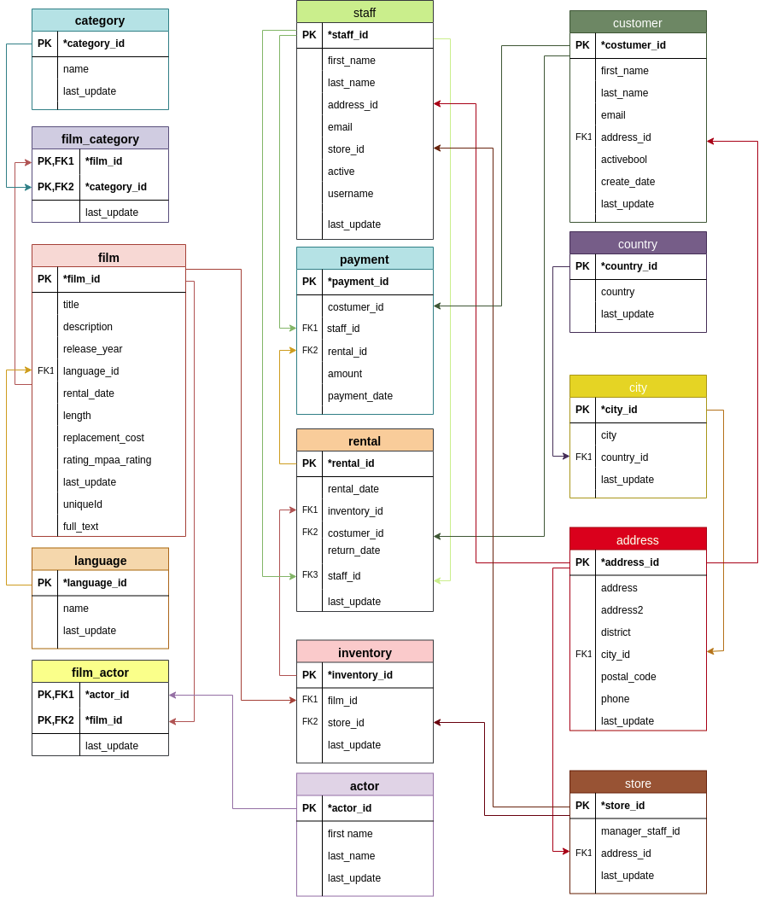

**3. Queries**

In this part we were required to implement some queries on the database using SQL. All of them have been passed through a SQL formatter so that they are readable (http://www.dpriver.com/pp/ sqlformat.htm).

1. Number of movies rented each year. The query must return two attributes containing the year and the number of films rented. Order the answer by the rental year in ascending order.

SELECT *Count*(*) AS number_rented_films,

**Extract** (year FROM rental_date) AS year *--PICKS THE YEAR OF THE DATE*

FROM rental

GROUP BY year

ORDER BY ( year ) ASC *--ORDERS THE YEAR ASC. AND COUNTS THE NUMBER OF FILMS RENTED EACH OF THEM*

1. Client who has rented more movies. If there is a tie between several clients, all clients with the maximum number of rented movies must appear in the response. The query must return the attributes: customer id, first name, last name and the number of rented movies.

SELECT first_name,

last_name,

customer.customer_id,

count

FROM customer,

(SELECT customer_id,

count

FROM (SELECT customer_id,

*Count*(*)

FROM rental

GROUP BY customer_id

ORDER BY *Count* (*) DESC) AS customer

*-- LIST OF HOW MANY MOVIES THE CUSTOMERS RENTED*

WHERE count IN (SELECT *Max*(count)

FROM (SELECT customer_id,

*Count*(*)

FROM rental

GROUP BY customer_id

ORDER BY *Count* (*) DESC) AS x)) AS id_client

*--X = CUSTOMER; ID_CLIENT SELECTS THE TOP ONE*

WHERE id_client.customer_id = customer.customer_id *-- CHOSE THE FIRST NAME, LAST NAME, ID AND COUNT*

1. List the cities where movies, in which “Bob Fawcett” appears, have been rented. Each city must appear just once. Sort the output alphabetically by the city name from A to Z. The query must return the city id and the city.name.

SELECT city.city_id,

city.city

FROM city,

(SELECT address.address_id,

address.city_id

FROM address,

(SELECT store.store_id,

store.address_id

FROM store,

(SELECT inventory_id,

inventory.store_id

FROM inventory,

(SELECT film.film_id

FROM film,

(SELECT film_id

FROM film_actor,

(SELECT actor_id,

first_name

FROM actor

WHERE first_name = 'Bob'

AND last_name = 'Fawcett'

) AS

actor_bob

*-- SELECTS THE NAME BOB AND LAST NAME FAWCETT*

WHERE film_actor.actor_id =

actor_bob.actor_id) AS

film_of_bob

*--SELECTS ALL THE FILMS IN WHICH HE APPEARS*

WHERE film.film_id = film_of_bob.film_id) AS

inventory_bob

*--SELECTS ALL THE MOVIES OF THE INVENTORY HE APPEARS*

WHERE inventory.film_id = inventory_bob.film_id) AS

store_bob

WHERE store_bob.store_id = store.store_id) AS store_id_bob

*--SELECTS ALL THE STORES THAT HAS THE MOVIES HE APPEARS*

WHERE store_id_bob.address_id = address.address_id) AS city_bob

*--SELECTS THE CITY ID IN WHICH THE STORE THAT HAS HIS FILMS ARE*

WHERE city_bob.city_id = city.city_id

GROUP BY city.city_id

ORDER BY city.city ASC *-- SELECTS THE NAME OF THE CITIES IN ALPHABETICAL ORDER*

1. Language in which most of the films have been filmed. The query must return the language.name attribute. If there is a tie between several languages, all languages in which the greatest number of films have been filmed should appear in the answer.

SELECT NAME

FROM language,

(SELECT language_id,

order_count

FROM (SELECT language_id,

*Count*(*) AS order_count

FROM film

GROUP BY language_id

ORDER BY *Count*(*) DESC) AS aviable_languages

*--SELECTS ALL THE AVAILABLE LANGUAGES*

WHERE order_count IN (SELECT *Max*(order_count)

FROM (SELECT language_id,

*Count*(*) AS order_count

FROM film

GROUP BY language_id

ORDER BY *Count*(*) DESC) AS x)) AS

id_movie *-- SELECTS THE TOP LANGUAGE IN WHICH MOVIES HAVE BEEN RECORD*

WHERE language.language_id = id_movie.language_id *--SELECTS THE NAME OF THE TOP LANGUAGE MOVIES HAVE BEEN RECORD*

1. Language (of the films) in which a greater number of rentals has been done. The query must return the language.name attribute. If there is a tie between several languages, all languages in which a greater number of rentals has been done must appear in the answer.

SELECT z.NAME

FROM (SELECT x.NAME,

*Count*(*) AS most_rented_movie

FROM (SELECT film_rental.NAME

FROM rental,

(SELECT inventory_id,

film_inventory.NAME

FROM inventory,

(SELECT film_id,

film_name.NAME

FROM film,

(SELECT language_id,

NAME

FROM language

GROUP BY language_id) AS film_name

WHERE film.language_id = film_name.language_id)

AS

film_inventory

*--SELECTS THE FILM ID AND THE NAME OF THE LANGAGE IT HAS BEEN RECORDED*

WHERE inventory.film_id = film_inventory.film_id) AS

film_rental

*--SELECTS THE ID OF THE INVENTORY THAT HAS THAT FILM*

WHERE film_rental.inventory_id = rental.inventory_id) AS x

*--IF THE MOVIE HAS BEEN RENTED AND IT IS IN THE INVENTORY IT TAKES THE NAME OF IT*

GROUP BY x.NAME

ORDER BY most_rented_movie DESC) AS z

*--SELECTS ALL THE TIMES A FILM HAS BEEN RECORD IN A LANGUAGE*

WHERE most_rented_movie IN (SELECT *Max*(most_rented_movie)

FROM (SELECT x.NAME,

*Count*(*) AS most_rented_movie

FROM (SELECT film_rental.NAME

FROM rental,

(SELECT inventory_id,

film_inventory.NAME

FROM inventory,

(SELECT film_id,

film_name.NAME

FROM film,

(SELECT language_id,

NAME

FROM language

GROUP BY language_id) AS film_name

WHERE film.language_id =

film_name.language_id)

AS

film_inventory

*--SELECTS THE FILM ID AND THE NAME OF THE LANGAGE IT HAS BEEN RECORDED*

WHERE inventory.film_id = film_inventory.film_id) AS

film_rental

*--SELECTS THE ID OF THE INVENTORY THAT HAS THAT FILM*

WHERE film_rental.inventory_id = rental.inventory_id) AS x

*--IF THE MOVIE HAS BEEN RENTED AND IT IS IN THE INVENTORY IT TAKES THE NAME OF IT*

GROUP BY x.NAME

ORDER BY most_rented_movie DESC)AS y)*--Y=SELECTS ALL THE TIMES A FILM HAS BEEN RECORD IN A LANGUAGE*

*---PICKS THE TOP LANGUAGE A FILM HAS BEEN RECORDED*

1. Favorite category (category.name) of the customer who has rented more movies. By favorite category we refer to the category in which the client has made more rentals. If a client rents the same movie twice it should count as two rentals. The query must return the name (category.name) and the identifier (category id) of the category. If there is a tie between several clients, all clients who have rented more films should appear in the response.

CREATE OR replace VIEW customer_and_num_rented_movies

AS

SELECT customer_id,

**Max**(count) AS num_film

FROM (SELECT customer_id,

category_id,

**Count**(category_id)

FROM (SELECT top_customer.customer_id,

film_category.category_id

FROM inventory,

rental,

film_category,

(SELECT customer_id

FROM (SELECT customer_id,

**Count**(*)

FROM rental

GROUP BY customer_id

ORDER BY **Count** (*) DESC) AS customer

WHERE count IN (SELECT **Max**(count)

FROM (SELECT customer_id,

**Count**(*)

FROM rental

GROUP BY customer_id

ORDER BY **Count** (*) DESC) AS

x)

)AS

top_customer *--TOP CUSTOMERS*

WHERE rental.inventory_id = inventory.inventory_id

AND rental.customer_id = top_customer.customer_id

AND inventory.film_id = film_category.film_id) AS

custumer_and_category

*-- PICKS THE CATEGORY ID OF ALL TH EMOVIES THE TOP CUSTOMERS RENTED*

GROUP BY category_id,

customer_id

ORDER BY category_id ASC) AS count_category

*--COUNTS ALL THE TIMES A DIFFERENT CATEGORY HAS BEEN RENTED FROM A DIFFERENT CUSTOMER*

GROUP BY customer_id; *-- IT GIVES YOU THE MOST RENTED CATEGORY OF THE TOP CUSTOMERS*

CREATE OR replace VIEW cost_and_category_id_count

AS

SELECT customer_and_num_rented_movies.customer_id,

count_category.category_id,

count_category.count

FROM customer_and_num_rented_movies,

(SELECT customer_id,

category_id,

**Count**(category_id)

FROM (SELECT top_customer.customer_id,

film_category.category_id

FROM inventory,

rental,

film_category,

(SELECT customer_id

FROM (SELECT customer_id,

**Count**(*)

FROM rental

GROUP BY customer_id

ORDER BY **Count** (*) DESC) AS customer

WHERE count IN (SELECT **Max**(count)

FROM (SELECT customer_id,

**Count**(*)

FROM rental

GROUP BY customer_id

ORDER BY **Count** (*) DESC) AS

x)

)AS

top_customer *--TOP CUSTOMERS*

WHERE rental.inventory_id = inventory.inventory_id

AND rental.customer_id = top_customer.customer_id

AND inventory.film_id = film_category.film_id) AS

custumer_and_category

*-- PICKS THE CATEGORY ID OF ALL TH EMOVIES THE TOP CUSTOMERS RENTED*

GROUP BY category_id,

customer_id

ORDER BY category_id ASC) AS count_category

*--COUNTS ALL THE TIMES A DIFFERENT CATEGORY HAS BEEN RENTED FROM A DIFFERENT CUSTOMER*

WHERE customer_and_num_rented_movies.num_film = count_category.count

AND customer_and_num_rented_movies.customer_id =

count_category.customer_id *-- PICKS THE CUSTOMER ID AND THE CATEGORY ID AND SHOWS HOW MANY TIMES A CATEGORY HAS BEEN RENTED*

SELECT * FROM customer_and_num_rented_movies

4. **DataBase Redesign**

In this exercise we were required to change the database so that if a staff member is transferred from one store to another, the information about the stores he had worked before are kept.

We added the following queries to the newdatabase.sql file:

﻿CREATE TABLE worked_in (

staff_id integer NOT NULL REFERENCES staff(staff_id),

store_id integer NOT NULL REFERENCES store(store_id),

PRIMARY KEY (staff_id, store_id)

);

To create a new table that has as primary key the staff id and the store id. That are foreing keys at the same time.

INSERT INTO worked_in VALUES

(1, 1);

(1, 2);

(2, 1);

We added those values at the table. The worker 1 has worked in the store 1 and 2. The number 2 has worked only in the first one.

1. We added the table **worked_in** to store the required information. This table contains foreign keys connected to **staff** and **store**. 